**Lab 3**

**Umamah Hussain**

**21L-1858**

**Q.1**

1. **List up to 4 different protocols that appear in the protocol column in the unfiltered packet-listing window.**

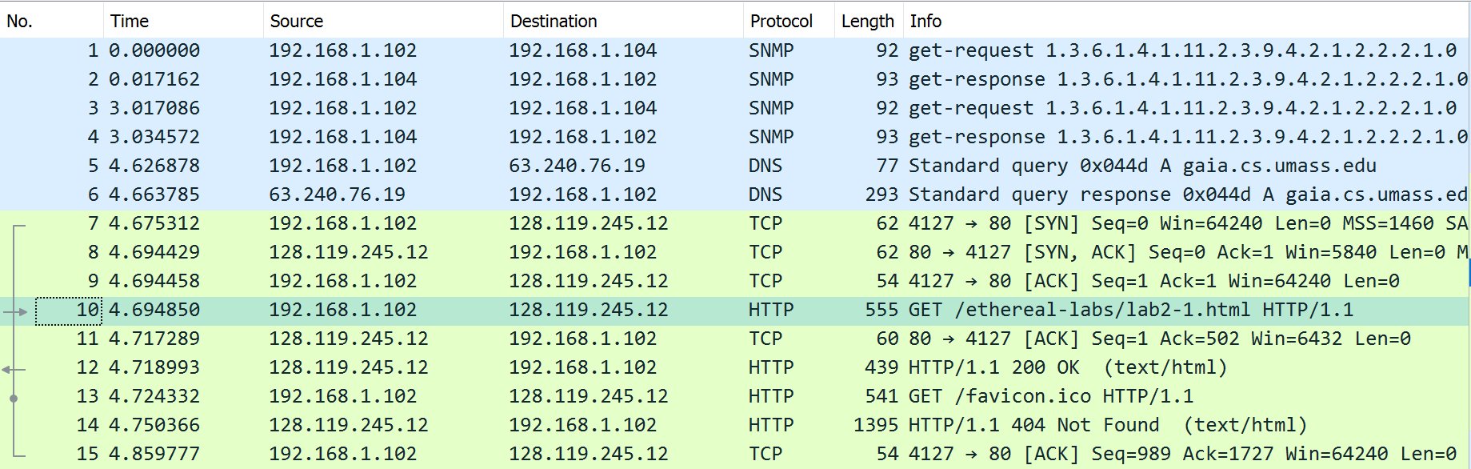

1. SNMP
2. DNS
3. TCP
4. HTTP

**2.) How long did it take from when the HTTP GET message was sent until the HTTP OK reply was received?**

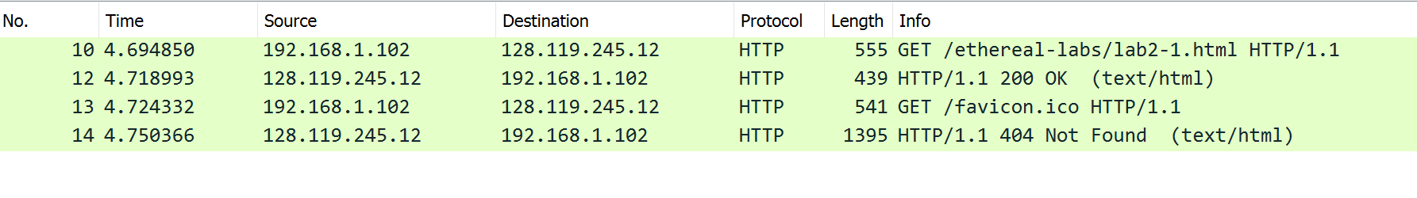

4.718993-4.694850=0.024143

1. **Was the second Get Request successful? How can you tell it from the corresponding response packet?**



It was not successful because it has sent a 404 error of NOT Found in response.

1. **Is your browser running HTTP version 1.0 or 1.1? What version of HTTP is the server running?**

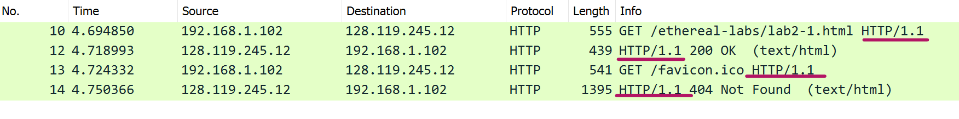

Both the client and server are using http 1.1.

1. **What languages (if any) does your browser indicate that it can accept to the server?**

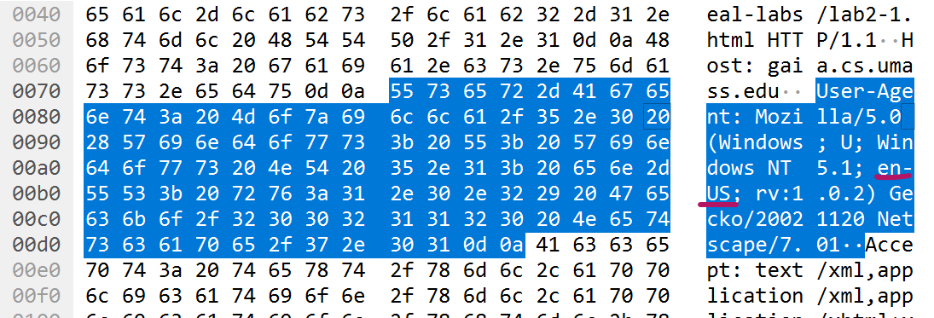

English-US

1. **What is the IP address of the gaia.cs.umass.edu server and your computer?**

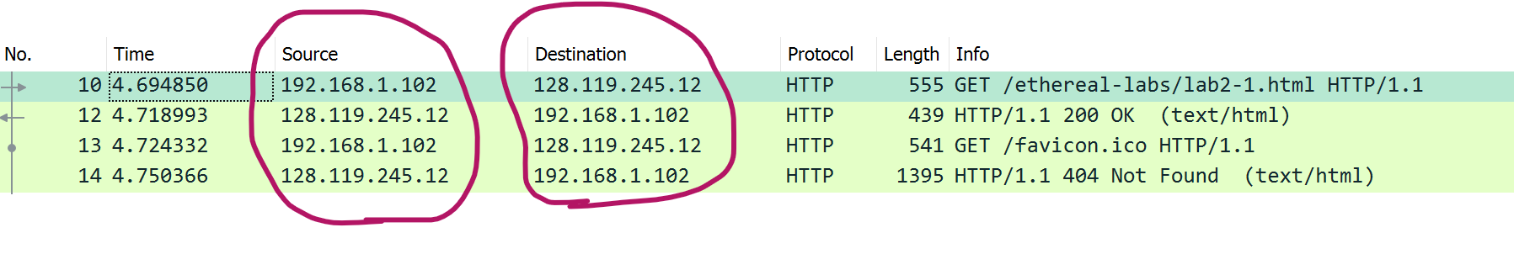

1. **What is the MAC address of the server and your computer?**

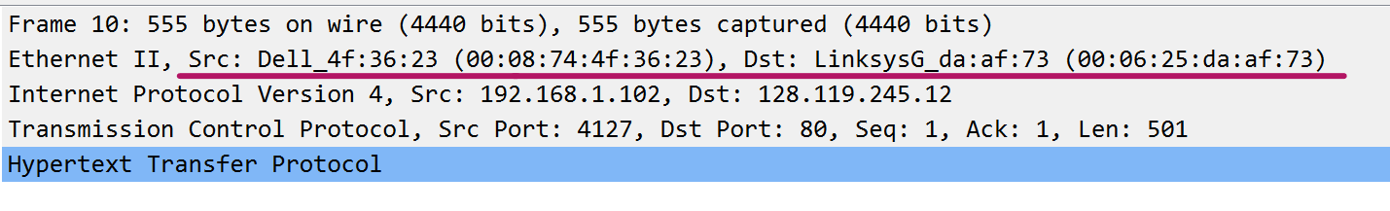

1. **What is sending and receiving Port Number? What does Port No. 80 represents?**

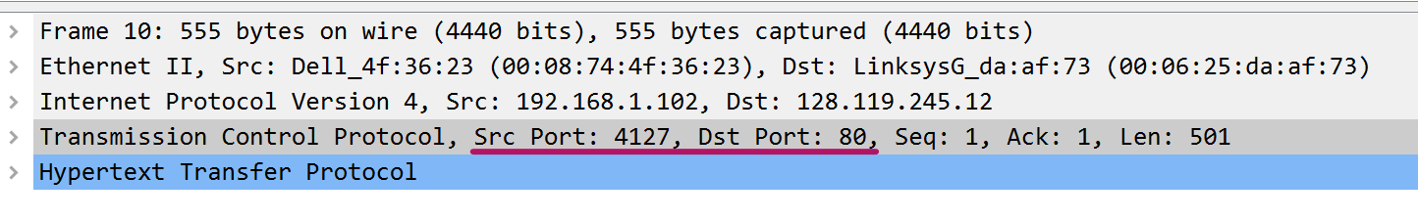

Port 80 is used for sending and receiving unencrypted web pages. It is the port assigned to http.

1. **What is the status code returned from the server to your browser?**

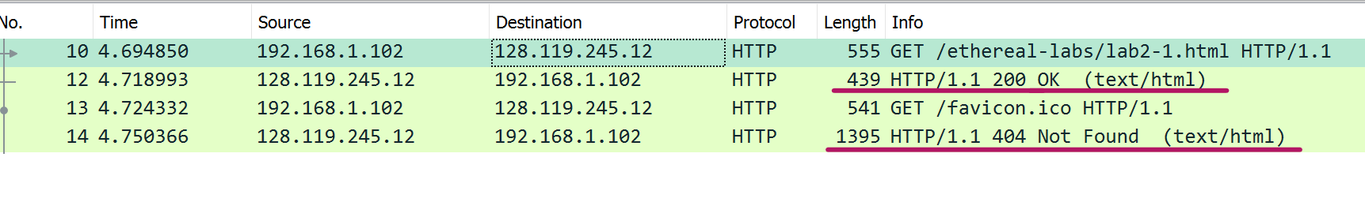

1. **When was the HTML file, that you are retrieving, last modified at the server?**

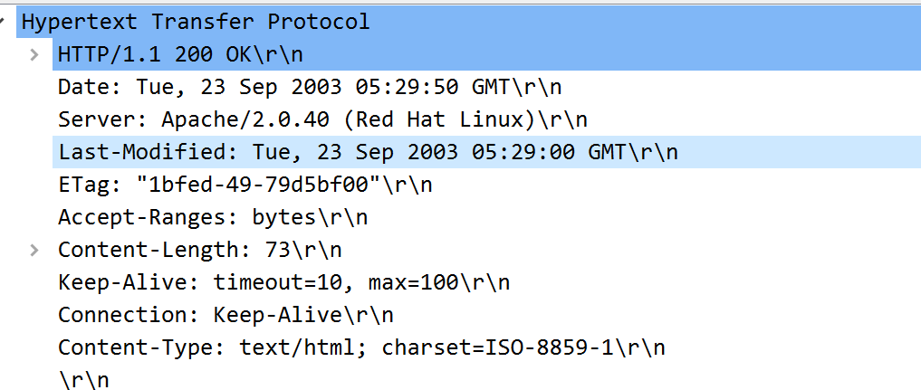

1. **How many bytes of total packet content are being returned to your browser?**

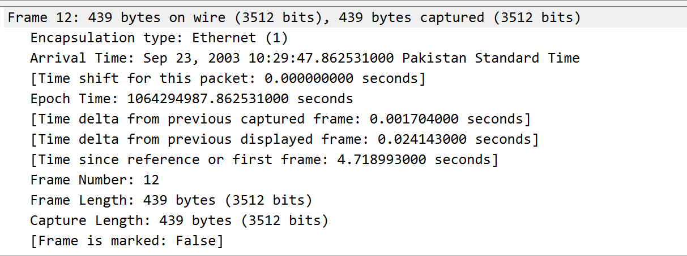

439 bytes

**Q.2**

1. **Inspect the contents of the first HTTP GET request from your browser to the server. Do you see an “IF-MODIFIED-SINCE” line in the HTTP GET?**

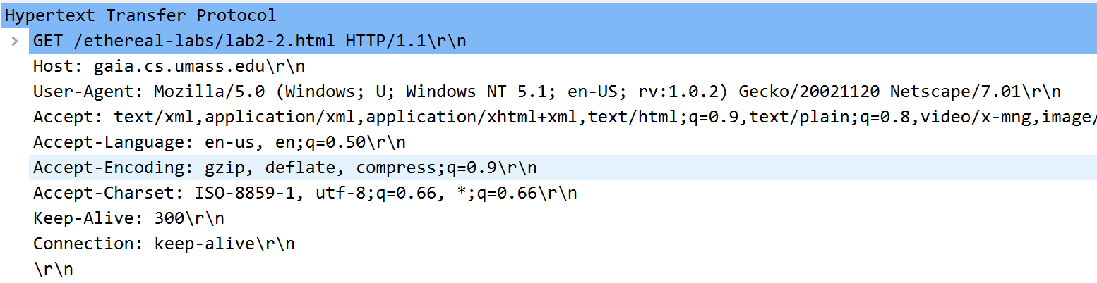

No I do not see the if-modified-since line

1. **Inspect the contents of the server response. Did the server explicitly return the contents of the file? How can you tell from the Packet Bytes Window?**

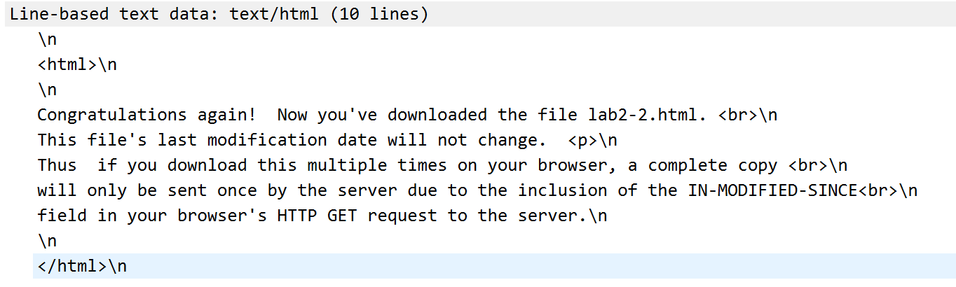

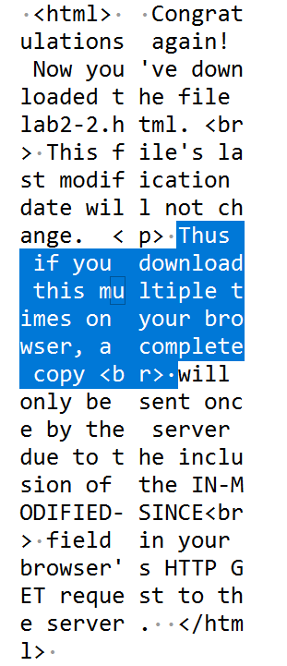

Yes it has explicitly returned the content of the file.

1. **Now inspect the contents of the second HTTP GET request from your browser to the server. Do you see an “IF-MODIFIED-SINCE:” line in the HTTP GET? If so, what information follows the “IF-MODIFIED-SINCE:” header? What is meant by this information?**

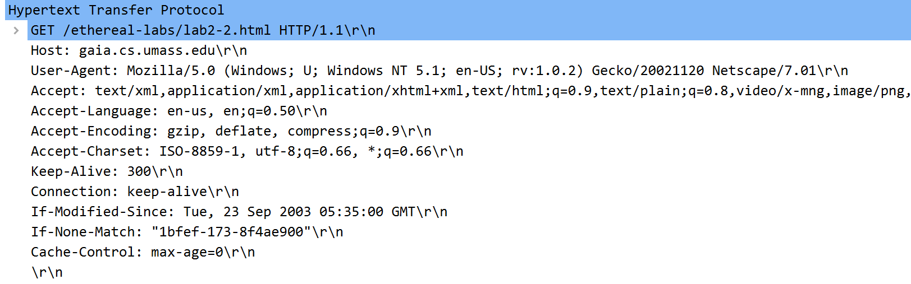

If-None-Match implies a conditional GET or Head. If the condition fails, an error code is returned which is 304 (Not Modified) which is being returned in our case. Thus, it’s evident that our condition is being failed.

1. **What is the HTTP status code and phrase returned from the server in response to this second HTTP GET? Did the server explicitly return the contents of the file? Explain your answer**

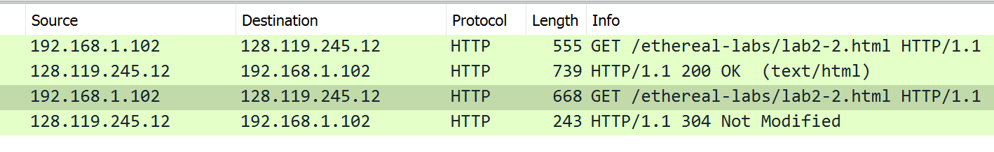

The 304 Status Code is returned and no the contents of the file were not returned.

**Q.3**

1. **How many HTTP GET request messages did your browser send?**



Only 1 GET request

1. **Which packet number in the trace contains the GET message for The Bill of Rights?**

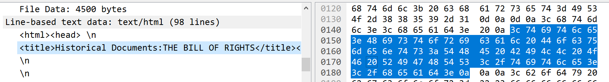

After conversion from hex to decimal 140 becomes 320 and 180 becomes 384.

1. **Which packet number in the trace contains the status code and phrase associated with the response to the HTTP GET request?**

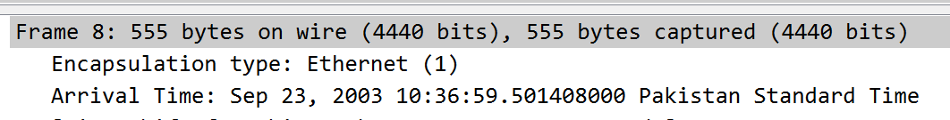

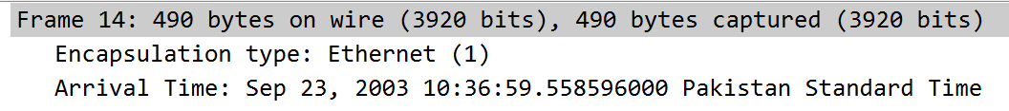

1. **What is the status code and phrase in the response?**

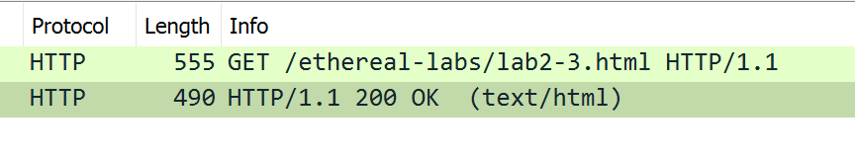

Status code is 200 and the phrase is OK

1. **How many data-containing TCP segments were needed to carry the single HTTP response and the text of the Bill of Rights? What are the numbers of those packets?**

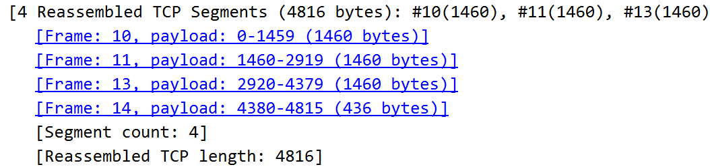

4 TCP packets were needed.

**Q.4**

**What is the length of the text for The Bill of Rights in bytes? How do you justify this length of text when your Response Packet Size is only 490 bytes? Give complete explanation how the length of text in various packets add up to a total of 4500 Bytes.**

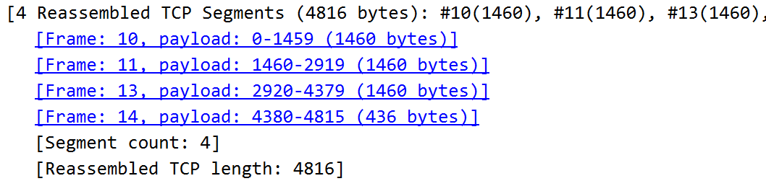



The Total Length is: 4816 bytes

Where as the content length of the file is 4500 bytes only

The extra space being utilized is by headers, flags and other meta data that is associated with every individual packet.